MYSQL FIRST DATABASE

Create a schema(database)

Create a table with all the necessary fields

1)

CREATE TABLE `usersdata`(db_name).`student`(table_name )(

`Id` INT NOT NULL,

`FirstName` VARCHAR(45) NULL,

`LastName` VARCHAR(45) NULL,

`Country` VARCHAR(45) NULL,

PRIMARY KEY (`Id`));

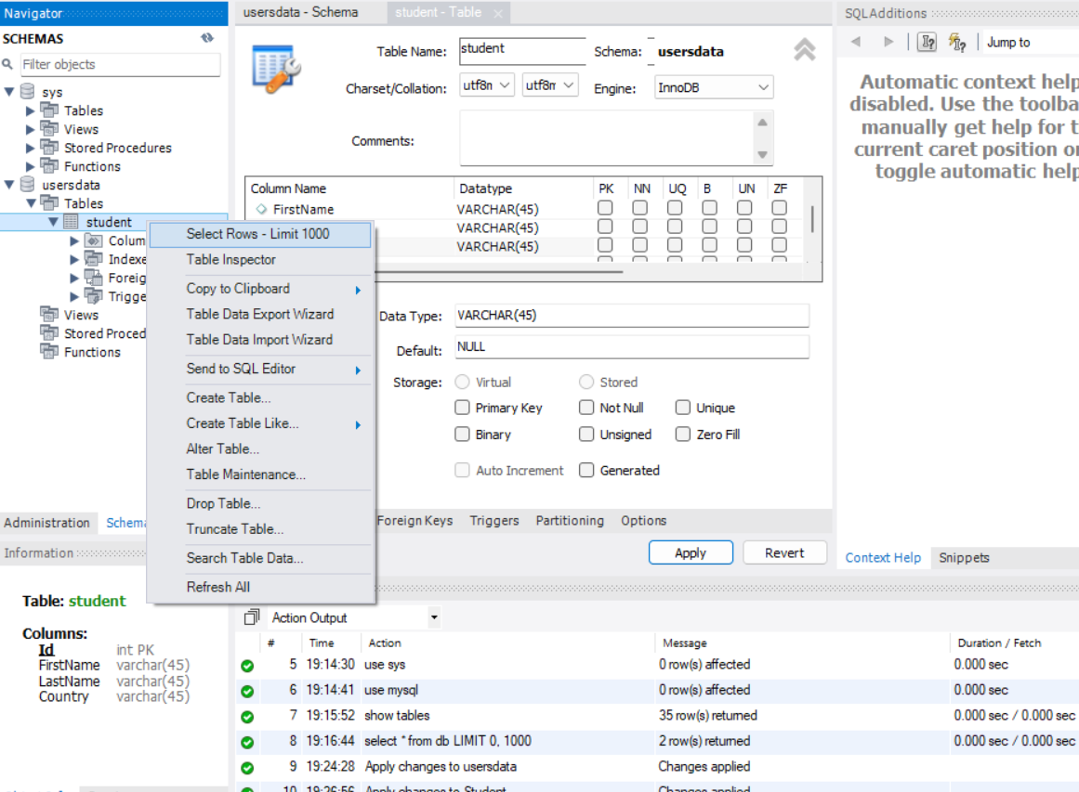

ALREADY FOUND commands, that could be done, we can even alter the table.



2) 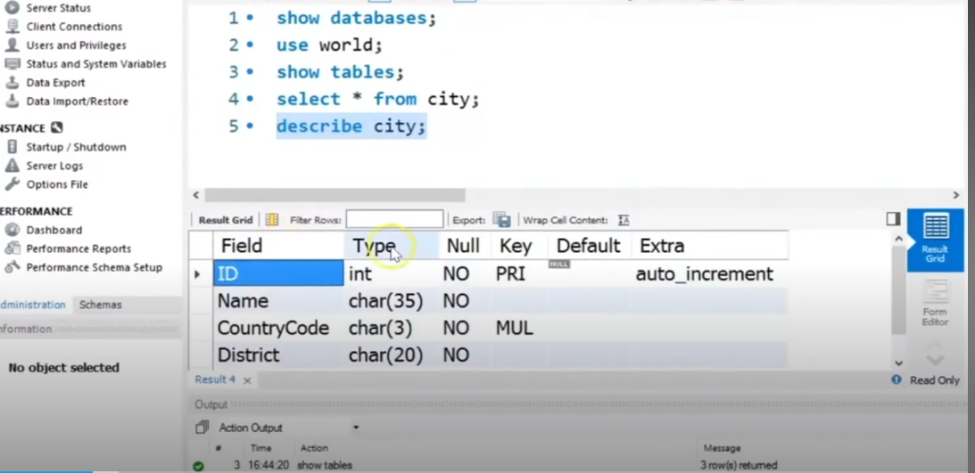

It describes the table, about its datatype key(prim or mul) and null values(found or not)



3)Creating a table using command:

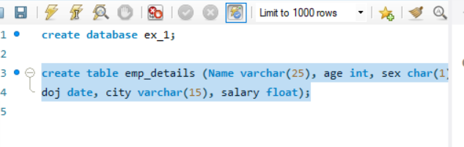

4)Inserting datas into the table:

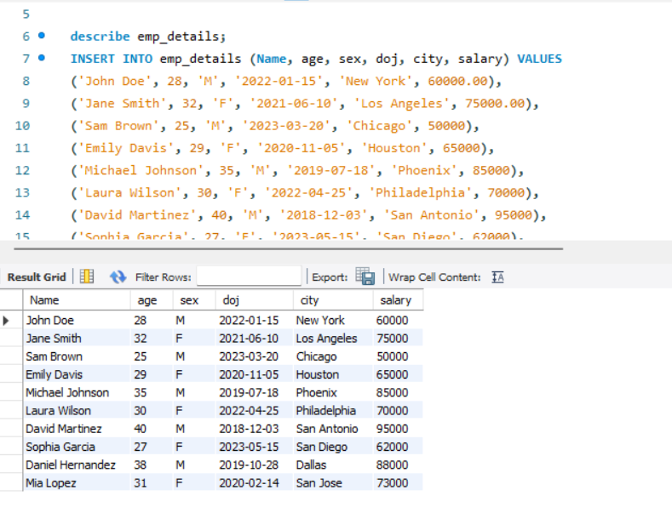

Distinct values:

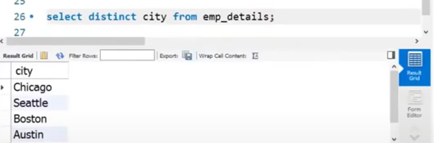

Count of employees found:

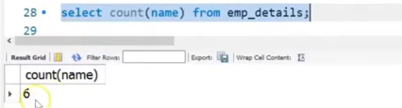

Alias:

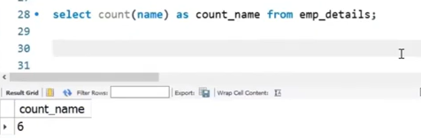

Sum of salaray:

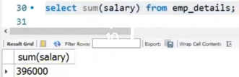

Average salary:

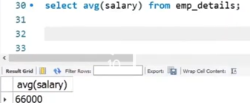

Select particular column:

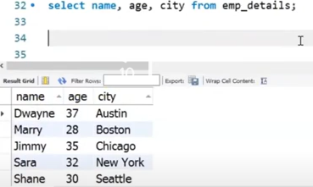

Employee Age greater than 30:

Female employees

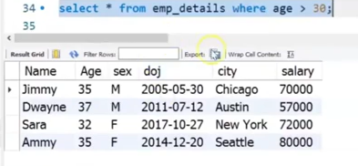 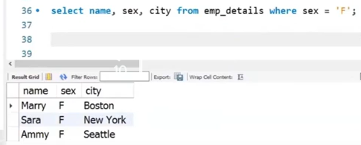

Select particular city:

Both of them mean the return same values

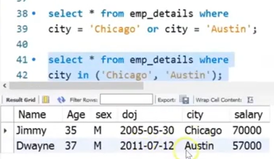



Between two doj:

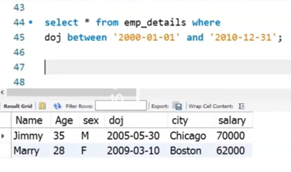

And operations:

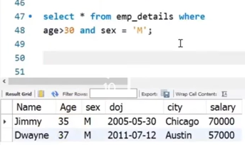

Group by statement(mostly used with aggregate functions):

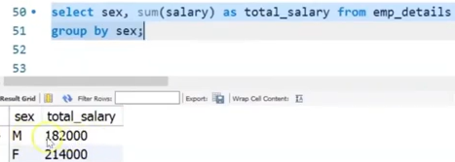

Order by keyword for sorting: salary column in ascending order.

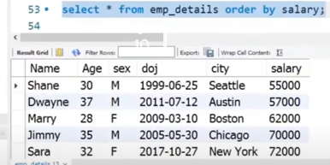

Expressions could be given and can be done

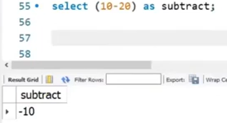

Length of the given string

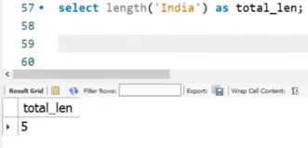

Repeat function- like for loop:

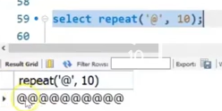

Lowercase of the given data:

Uppercase of the given data:

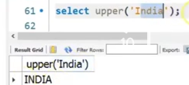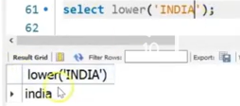

If I want the current date☹DATE AND TIME FUNCTIONs:

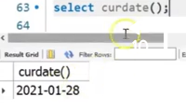

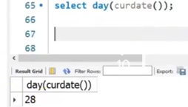

Current day date is printed



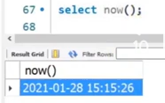

Current date along with the time



#STRING FUNCTIONS:

1)upper() -uppercase function

2)lower() -lowercase function, there is another function in which lower function is implemented:

lcase()

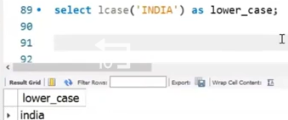

3)length() or we can also use character_length() or char_length:

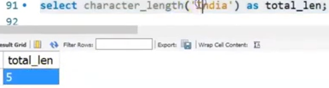

1)WE can aslo use these functions in the stable- for example we need the length of the name of each of the student:

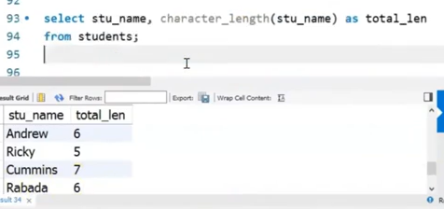

4)concat function:

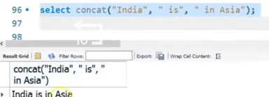

In table- student id follwed by student name: student name and age is concatenated:

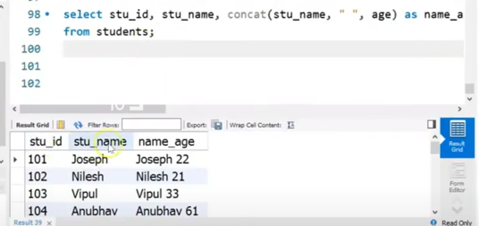

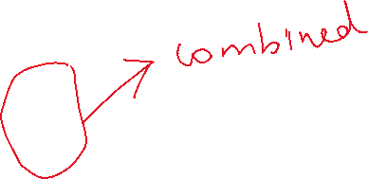

5) Reverse a string:

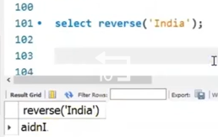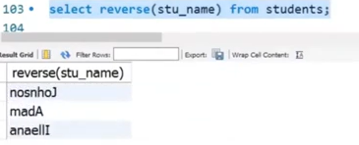

In table: reverse the names of the student

6)Replace function:

Syntax:

Replace(sentence,one that will be replaced, the one which will appear in new)

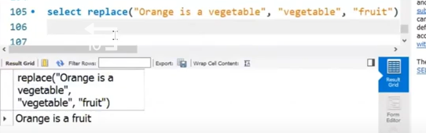

7) Trim function is also used in the sql:

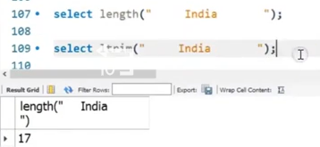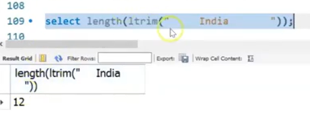

LEFT TRIM- DELTES LEADING SPACES

8)Right trim:

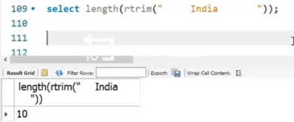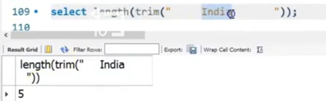



9) Position of the given word in a given string:

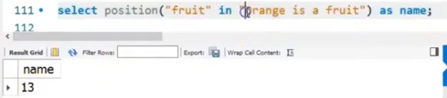

10)return ascii value:

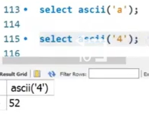

GROUP BY FUNCTION:

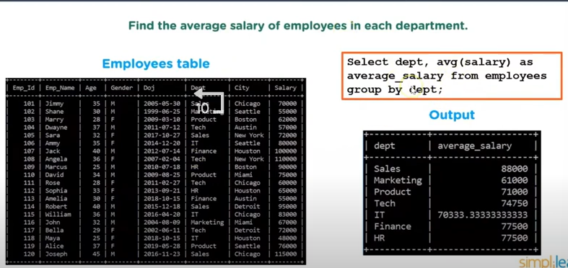

The aggreagte function is used- avg() and thy are grouped by dept- for each dept the average salary is given

2)another exAMPLE- avg of all employees in each dept:

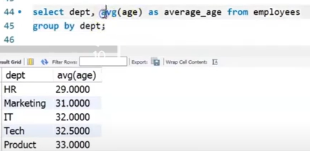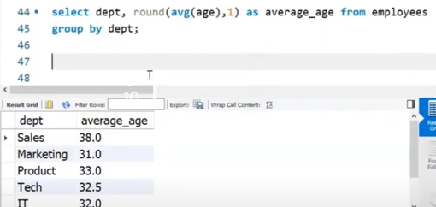

Round(value,decimal place) – is given where we are able to obtain the rounded value along with the decimal places number.

3)total salary in each dept:

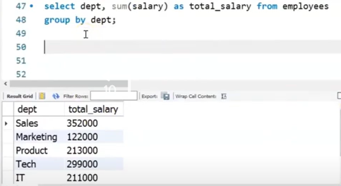

NOTE: We can also use order by clause along with group by clause.

4)No of employees joined each year:

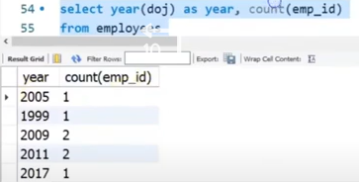

5)Another database created☹SALES DATABASE)

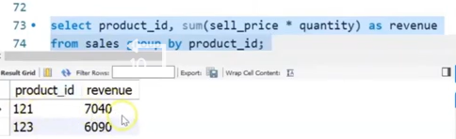

Created two databases- one with selling price and sales details. Other with cost price where they have the common product id. In the given below clause, we find that we are calculating the profit whenever the both cost price id and the selling price id are same by using INNER JOIN

Profit calculation:

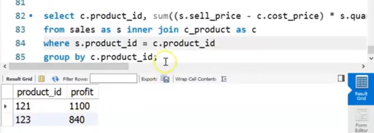

HAVING CLAUSE:

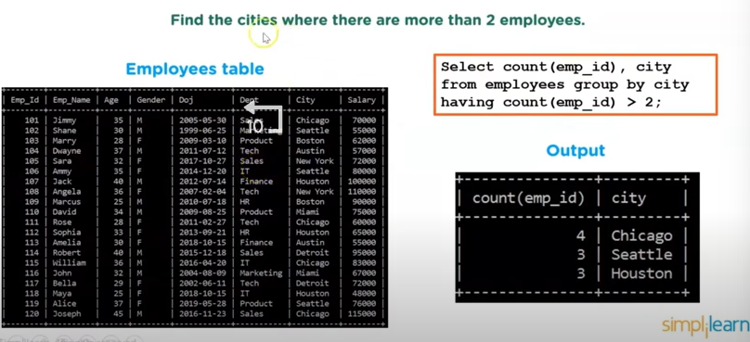

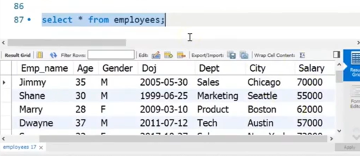

Predefined data set for the employee table:

1)Now we have to find the avg salray of all the depts whose avg salaray is greater than 75000:

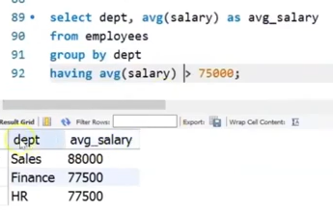

2)Cities(GROUP BY) whose sum of salray is greater than 200000:

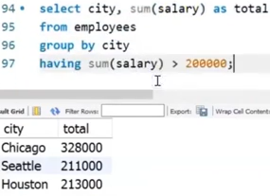

3) To return the values of the count of employees grouped based on the dept- where the number of employees in a dept is greater than the 2 employees .

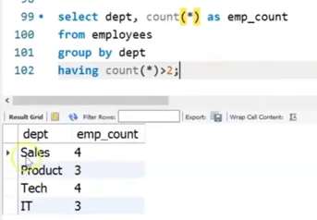

4) We can use where clause along with the having clause:

I want to store the employess based on their citiies where the citry is not “HOUSTON” and also the count value of employees is greater than 2 members:

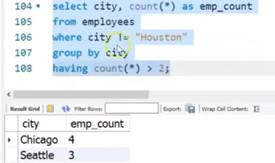

5)Aggregate function in having clause which is not in the select :

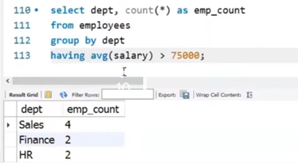

JOINS IN SQL:

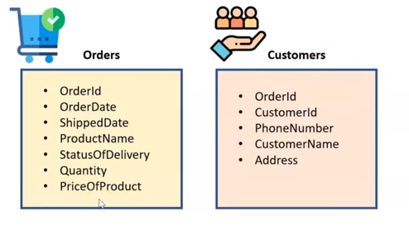





Another example: in which the name of the customers from column2 who have ordered in last 30 days from orderdate in column1:

INNER JOIN:

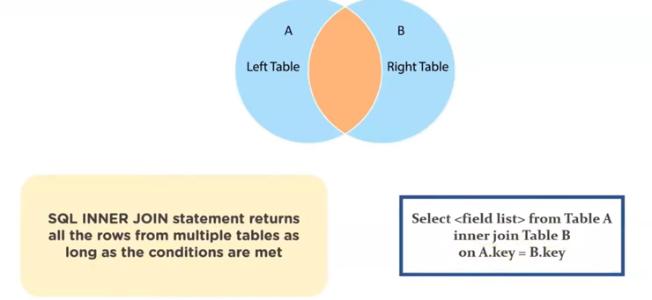

To perform inner join :

1)CRICKET TABLE

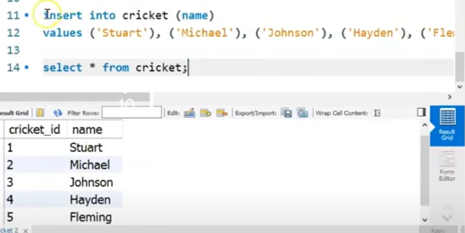

1)FOOTBALL TABLE

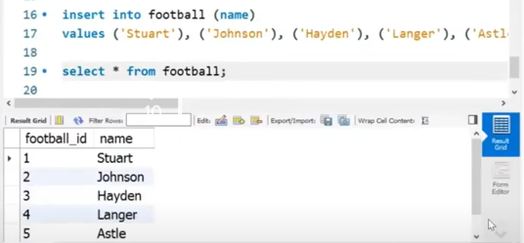

We want to find the students who is both the part of cricket as well as football:

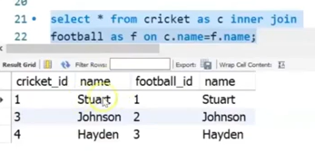

This can aslo be written in another name by calling all the columns using function :

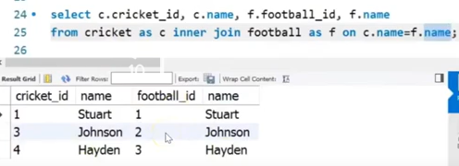

Same output is actually obtrained in both the cases

**3)ANOTHER EXAMPLE:**

We are using two tables:

Products and productlines:

Suppose we want to find the product code(in column 2) for each of the product(in column1):

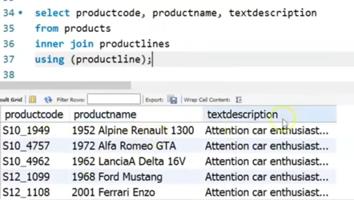



Through the using function we can perform the similar function like:

Product.productline=productlines.productline- imp

**4) Another example:**

We have teo tables orders and orderdetails:

Now I am going to product orders and oderdetails we will join them:

Quantity ordered * price of each product- and calculate their sum and name it as revenue.

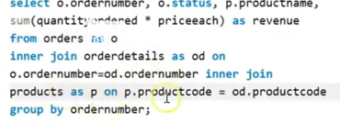

3 different tables are been combined in this case – first order and orderdetails table where joined using ordernumber as common and then used another inner join to join products and orderdetails table using the product code as common.

At last it was grouped by ordrenumber-according tot the order number the revenue details were collected and grouped only if those product code matched with the above values then the product name was printed.

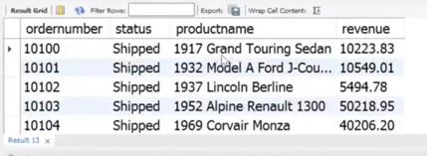

**LEFT JOIN:**

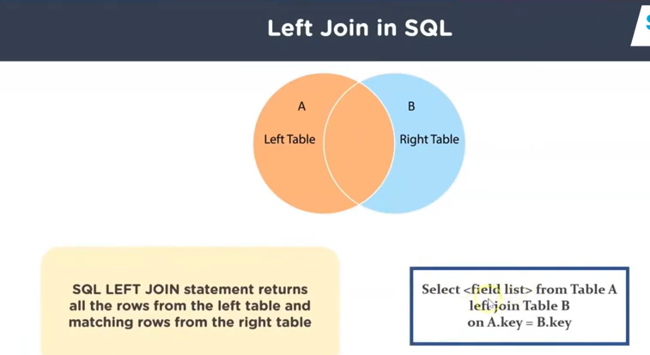

**W3 SCHOOLS CONTINUATION(FROM EXISTS)**

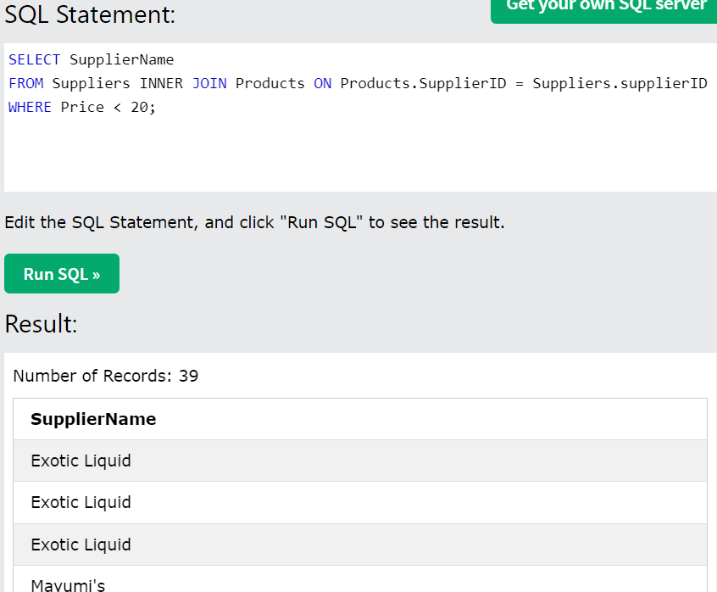

Here we find that the repeated values are also taken into account and thus we find that the number of records are more.

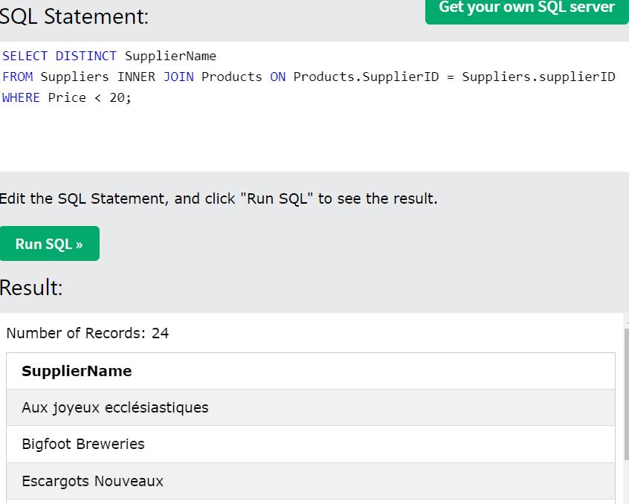

Unique values are obtained. only 24 records are found- Another way of writing this same code using the WHERE EXISTS can be done also remember that we can combine two tables in subquery (one which is inside the sub query and that which is outside the subquery)

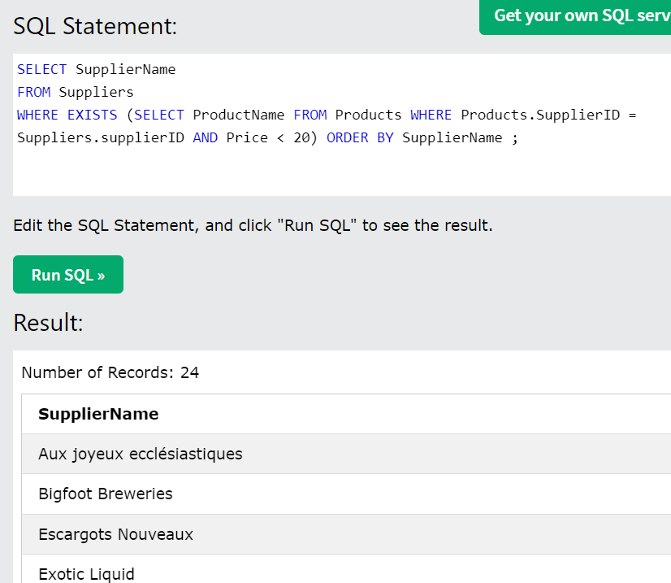

Another way of combining two tables.

The subquery if executed alone without the outer query then it will result in error.

EXIST()-paranthesis consist of the subquery inside it



ANY AND ALL OPERATOR: